The peculiar history of the Pledge of Allegiance

Story highlights
- The words of the pledge of allegiance have changed over the years.
- The original motion for the pledge was called “The Bellamy Salute.”
- WWII changed the way people viewed the salute.
- Today, people often place their hands over their hearts when saying the pledge.

In its original form, the pledge read:
"I pledge allegiance to my Flag and the Republic for which it stands, one nation, indivisible, with liberty and justice for all."

An Embarrassing Situation

Seventy one years ago -- December 22, 1942
-- Congress got the United States out of what
had turned into an unexpectedly embarrassing
situation. It concerned the Pledge of Allegiance
-- specifically, something called the Bellamy Salute. Most people today have likely never heard of it, but the Bellamy Salute was once a constant part of the country's life.

A Boost of Patriotism
Until 1892, there was no such thing as a Pledge of Allegiance. Daniel Sharp Ford, the owner of a magazine called Youth's Companion, was on a crusade to put American flags in every school in the country. He sensed that the U.S. needed a boost of patriotism. Keep in mind: Not even 30 years before, the Civil War had still been raging. National unity was a fragile concept.

As part of the campaign, Sharp gave an assignment to a member of his staff: Francis J. Bellamy, who was an author, a minister and an advocate of the tenets of Christian socialism. Sharp asked Bellamy to compose a Pledge of Allegiance to the flag. Bellamy wrote it, and it was published in the magazine. It didn't take long for the Pledge to become wildly popular, even omnipresent. At schools, at campgrounds, at public gatherings, in Congress, people routinely faced the flag and pledged their allegiance to it.
In 1923, the words, "the Flag of the United States of America" were added. At this time it read:

"I pledge allegiance to the Flag of the United States of America and to the Republic for which it stands, one nation, indivisible, with liberty and justice for all."

The Bellamy Salute

Because, inherently, there is something physically awkward about people simply standing in place, their arms hanging limply by their sides, staring at a flag and reciting a pledge, it was decided that devising a salute would be appropriate.

Instructions for carrying out the salute were printed in the pages of Youth's Companion. The gesture came to be called the Bellamy Salute, in honor of the Pledge's author.

The Bellamy Salute consisted of each person -- man, woman or child -- extending his or her right arm straight forward, angling slightly upward, fingers pointing directly ahead. With their right arms aiming stiffly toward the flag, they recited: "I pledge allegiance..."

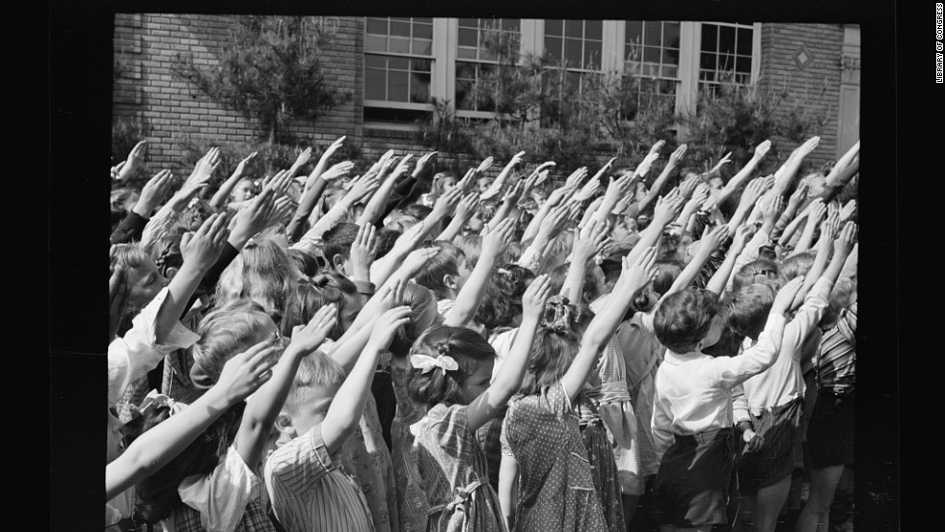
Southington, Connecticut school children pledge their allegiance to the flag, in May 1942.
WWII Symbolism
For a while, the salute wasn't especially controversial. But, as World War II was forming in Europe, and Italians and Germans began saluting Benito Mussolini and Adolf Hitler with extended-armed "Heil Hitler!"-style gestures… Well, perhaps you can see the problem.
In the United States there was a growing feeling of discomfort that, when people within the nation's own borders pledged their right-arms-extended allegiance to the flag, they might be construed as inadvertently showing solidarity with the fascist regimes across the ocean. Richard J. Ellis, in his book "To the Flag: The Unlikely History of the Pledge of Allegiance," wrote that "the similarities in the salute had begun to attract comment as early as the mid-1930s."

Newsreels and still photos were regularly depicting rallies in Europe's dictatorships, with thousands of people showing their fealty by extending straight-armed salutes. In the United States, the general unease about it -- "the embarrassing resemblance between the 'Heil Hitler' salute and the salute that accompanied the Pledge of Allegiance," in Richard Ellis's words -- was combined with the fear that scenes of Americans offering the Bellamy Salute could be used for propaganda purposes.
It wouldn't be terribly difficult to crop the American flag out of photos of U.S. citizens reciting the Pledge of Allegiance; without the flag in the shots, the photos could be mischaracterized as proof that Americans were expressing support for the ideologies of Hitler and Mussolini.

Thus, on December 22, 1942, Congress, just before its Christmas break, took care of it. On that day, the amended Flag Code was passed, Section 7 of which decreed that the Pledge of Allegiance should "be rendered by standing with the right hand over the heart."
And with that, it became official: Those millions of extended right arms were brought down. The stiff-armed salute was for other people, in countries far away. It was purely symbolic, of course, but symbols are powerful.

Controversy
Over the years, there have been various disputes about the Pledge of Allegiance, the most basic of which is the question of whether citizens should even be expected to publicly pledge their allegiance to their country. The United States was founded on ideals of freedom, and freedom includes not being forced, or cajoled by peer pressure, into publicly declaring any belief.

The exact wording of the Pledge has changed several times since Francis Bellamy wrote it; each change was reflective of contemporaneous concerns about the meaning. For example: "I pledge allegiance to the flag" was originally "I pledge allegiance to my flag." The "my" was dropped out of worries that recent arrivals from other nations might be seen as pledging their loyalty to the flag of the country of their birth.
The most significant change in the wording came in 1954, when -- with the enthusiastic support of President Dwight D. Eisenhower -- the phrase "under God" was added just after "one nation." Eisenhower declared: "In this way we are reaffirming the transcendence of religious faith in America's heritage and future; in this way we shall constantly strengthen those spiritual weapons which forever will be our country's most powerful resource in peace and war."
In 1954, in response to the Communist threat of the times, President Eisenhower encouraged Congress to add the words "under God," creating the 31-word pledge we say today. Today it reads:

"I pledge allegiance to the flag of the United States of America, and to the republic for which it stands, one nation under God, indivisible, with liberty and justice for all."

Conclusion
The wording of the Pledge of Allegiance may or may not be changed again in centuries to come, but it's a pretty safe bet that the Bellamy Salute is never coming back. Once ubiquitous and unquestioned, it has become a faded and mostly forgotten bit of U.S. history.
All because, 71 Decembers ago, a solution to a quandary -- a quandary no one could have anticipated when the Pledge was written. So ---
Lower those stiff arms.
Bend those elbows.
Direct those palms inward.
And take them to heart.

Sources:
Bob Greene, CNN Contributor, 12/23/13. http://edition.cnn.com/2013/12/22/opinion/greene-pledge-of-allegiance-salute/
US History, ushistory.org, “Historic Documents.” http://www.ushistory.org/documents/pledge.htm

Answer these questions on a separate sheet of paper. Write your name (first and last), core #, and “Due Date: 1/27/2017” at the top of the page.

Survey (view with intent)
- title, headings, and subheadings
- captions under pictures, charts, graphs or maps
- Based on this survey, what do you expect the article to be about? Use complete sentences and begin your answer with: “Based on the heading, subheadings, and images in this article, I expect the story to be about …”
- Introduction, conclusion, summary
- What are the children in the picture doing?
- What is the main idea of the introduction?
- What is the main idea of the conclusion?
- There is a summary in this article. What is the heading of the summary?
Question
- Read the questions below related to this article before reading the article.
Read
- Look for answers to questions from chapter and from teacher-provided questions.
- Read all captions (images, maps, …)
- Slow down for difficult text.
- Stop and reread parts that are unclear.
- Read only one section at a time.

Questions for this article. Use complete sentences to answer these questions.
- Why did Daniel Ford believe that it was important to have flags in the classroom?
- Why did the author feel “National unity was a fragile concept” when he wrote his article in 1892?
- What were the words of the original pledge?
- Why did the Bellamy Salute become controversial after WWII? Your answer should be at least 5 sentences long and use textual evidence.
- The article states that symbols are powerful. Write 2-3 sentences about the power of other symbols. If you cannot think of any, write about the symbolism of burning an American flag from the perspective of those who burn it and those who are upset seeing it burned. Remember, your answer needs to relate to the symbolism.
- What was the last change made to the pledge?

Rephrase
- Highlight notes from the text but write the information in your own words.
- Ask yourself questions about what you just read.
- Reread the “Conclusion” section,” and define the words below in your own words.
Ubiquitous
quandary

