Name:______________________________ CORE:_________
Rhetoric Devices
Ethos, Pathos and Logos are important rhetorical devices that are used to “connect” the audience to what is being spoken or written about. These devices can convince audiences to sway to a certain point of view if used strategically.
Use the Shmoop video to fill in the blanks.: https://www.youtube.com/watch?v=gf81d0YS58E
Ethos means ____________________________.
Pathos makes a person stop ____________________ and start __________________.
Logos is when you explain to your reader/listener in ___________________ and _________________ terms. You are also making them believe that thinking any other way is stupid.

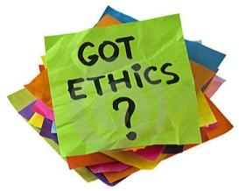
Ethos or the ethical appeal, means to convince an audience of the author’s credibility or character. An author would use ethos to show to his audience that he is a credible source and is worth listening to. Ethos is the Greek word for “character.” The word “ethic” is derived from ethos. Ethos can be developed by choosing language that is appropriate for the audience and topic (also means choosing proper level of vocabulary), making yourself sound fair or unbiased, introducing your expertise or pedigree(degrees), and by using correct grammar and syntax.

Pathos or the emotional appeal, means to persuade an audience by appealing to their emotions. Authors use pathos to invoke sympathy from an audience; to make the audience feel what the author wants them to feel. A common use of pathos would be to draw pity from an audience. Another use of pathos would be to inspire anger from an audience; perhaps in order to prompt action. Pathos is the Greek word for both “suffering” and “experience.” The words empathy and pathetic are derived from pathos. Pathos can be developed by using meaningful language, emotional tone, emotion evoking examples, stories of emotional events, and implied meanings.
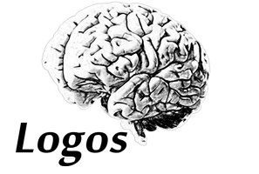Logos or the appeal to logic, means to convince an audience by use of logic or reason. To use logos would be to cite facts and statistics, historical and literal analogies, and citing certain authorities on a subject. The word “logic” is derived from logos. Logos can be developed by using advanced, theoretical or abstract language, citing facts (very important), using historical and literal analogies, and by constructing logical arguments.
Kairos Kairos is a “call to action” or words that express a kind of urgency. Kairos actually means “the opportune time”. Thus, when using kairos in rhetoric, the words are designed to make an appeal to the audience is that the time is NOW to take some kind of action and/or expressing, very emphatically, what is appropriate in a given situation.

Practice: Use the following information to write an argument saying that child labor needs to be stopped using each type of rhetoric.
Child labour refers to the employment of children in any work that deprives children of their childhood, interferes with their ability to attend regular school, and that is mentally, physically, socially or morally dangerous and harmful.^{[3]} This practice is considered exploitative by many international organisations. Legislations across the world prohibit child labour.^{[4][5]} These laws do not consider all work by children as child labour; exceptions include work by child artists, supervised training, certain categories of work such as those by Amish children, some forms of child work common among indigenous American children, and others.^{[6][7][8]}

Silk weaving
A 2003 Human Rights Watch report claimed children as young as five years old were employed and worked for up to 12 hours a day and six to seven days a week in silk industry.^{[127]} These children, HRW claimed, were bonded child labour in India, easy to find in Karnataka, Uttar Pradesh and Tamil Nadu.^{[128]}
In 2010, a German news investigative report claimed that in silk weaving industry, non-governmental organisations (NGOs) had found up to 10,000 children working in the 1,000 silk factories in 1998. In other places, thousands of bonded child labour were present in 1994. After UNICEF and NGOs got involved, after 2005, child labour figure is drastically lower, with the total estimated to be fewer than a thousand child labourers. The released children were back in school, claims the report.^{[129]}

Type of rhetoric | Your 2-4 sentence argument using each type of rhetoric  Child labor should end.
Ethos
Pathos
Logos
Kairos

