Name: _________________________________________ Core: ________
Annotation ____/20 Questions ____/80 Total Score: ________
Annotation Guideline:
- Circle and define unknown words or ideas
- Write the question number next to the sentence(s) where the answer is found.
- Add comments about connections you have about the text
- Write questions you have about the topic
- Write reactions (emotions the text makes you feel and why)
How Social Media Aided The Fight Against Injustices In 2014
By Meera Dolasia on January 4, 2015
2014 will be remembered for many things - the re-emergence of Ebola, cyber attacks on corporations like Target, Home Depot and Sony, and most importantly, numerous extraordinary protests. Though the reasons for the public rallies that occurred in cities all across the globe differed, they had one thing in common - their success can be largely attributed to the use of social networking sites like Facebook and Twitter, which helped raise worldwide awareness and brought like-minded people together to organize effective campaigns that lasted for months, some even continuing into 2015.
#Euromaidan (Ukraine)
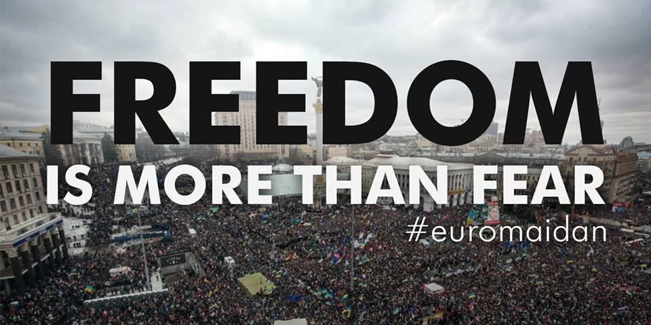
The unrest in Ukraine began in November 2013, after President Viktor Yanukovych decided to suspend trade talks with the European Union. A small group converged at the "Maidan Nezalezhnosti" or Independence Square in the capital city of Kiev to voice their displeasure. Without the reach of social media, the small gathering would have probably succumbed to the demands of the local authorities and petered out within a few days.
But thanks to twitter feed #Euromaidan (the "Euro" indicating the protestors admiration for Europe's genuine democracy and "maidan" paying homage to the venue of the start of this and the 2004 Orange Revolution that began at the same square), the small uprising transformed into a full-fledged revolt that resulted in the ouster of Viktor Yanukovych in February 2014.
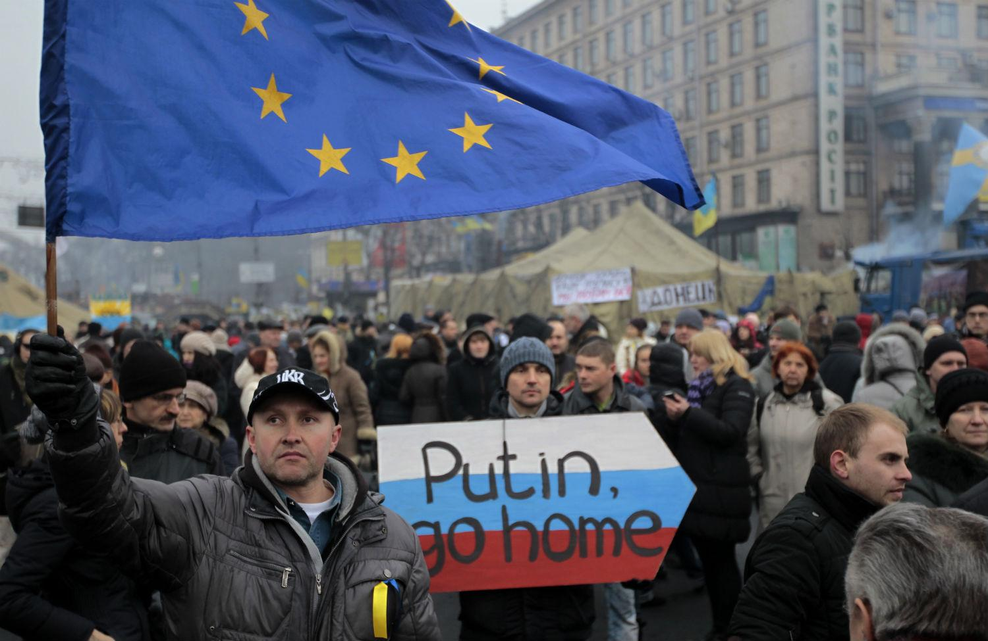
Unfortunately that was not enough to solve the country's problems. On March 18th, 2014, Russian President Vladimir Putin laid claim to Crimea, which has been part of Ukraine since 1954. This has led to well-founded fears that Putin's ultimate goal is to make Ukraine a "protectorate" of Russia. Since then, pro-Russian separatists and Ukrainian forces have been engaged in a serious conflict, one that shows no signs of abating.
#SOSVenezuela (Venezuela)
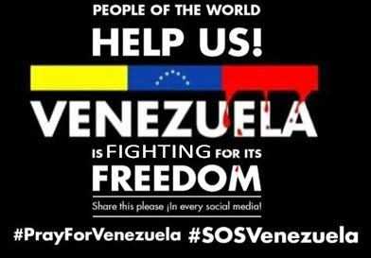
Tired of soaring inflation, goods shortages and escalating crime rates, Venezuelan students took to the streets in February 2014, to protest against the policies of the newly-elected President Nicolas Maduro. However, it was not until February 12th, when opposition leader Leopoldo López called for a peaceful nationwide protest that the world began to pay attention. The people's plight was captured in the endearing #SOS Venezuela campaign. The campaign, which was started by Caracas-based activist group Un Mundo Sin Mordaza (A World Without Censorship), helped raise global awareness of the country’s problems.
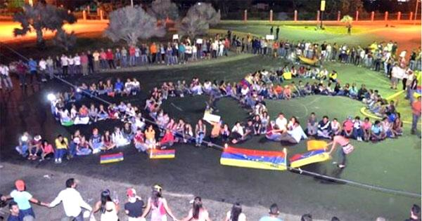
As more people joined in the movement, the clashes between the security forces and the protestors increased. On February 18th, the officials arrested Lopez on what the protestors assert are false charges. Despite several attempts to free him, Lopez remains in jail. With no leader at the helm and a violent crackdown by the ruling government, the movement has lost some steam. However, given the increasing discontent with the current regime, the possibility of additional unrest remains strong.
#BringBackOurGirls (Nigeria)
On April 14th, 2014, Islamic militant group Boko Haram kidnapped 270 girls from Chibok boarding school in northeastern Nigeria. While 57 girls managed to escape from the captors the first night, the rest have not been seen since. In an attempt to garner world attention, a group of locals started the #BringBackOurGirls campaign. Not surprisingly, the plea went viral, catching the attention of even US First Lady Michelle Obama.
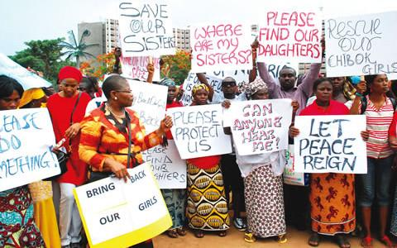
But despite worldwide appeals there has been no progress in locating the kidnapped girls. What is even more unfortunate is that the world has moved on to deal with other more pressing issues. However, the girls' families and friends still rally in Nigeria's capital city of Abuja each week, pleading for the same thing: Bring Back Our Girls!
#HandsUp, #HandsUpDontShoot & #BlackLivesMatter (USA)
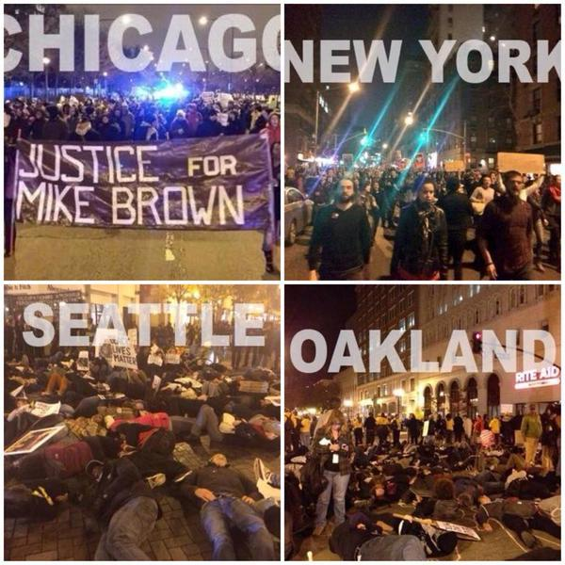
On August 9th, 2014, African American teenager Michael Brown was fatally wounded by a white police officer in Ferguson, Missouri, sparking weeks of protests in the area. The situation was exacerbated when a grand jury absolved the officer of all charges on November 24th. After an eyewitness described the unarmed Brown raising his hands in the air just prior to being shot, the gesture of surrender and the slogans "Hands Up" and "Hands Up, Don't Shoot", became the symbol for the nation's outrage at the injustice.
A few days later, a different grand jury announced their decision not to indict another white police officer in a similar incident that occurred in Staten Island, New York, on July 17th, 2014. In this case, 34-year-old Eric Garner, who also happened to be African American, died after being held ia choke-hold by the policeman.
Garner's final words "I can't breathe," along with "Black Lives Matter" in support of both deaths, has also been adopted as a slogan by protestors. Thanks to the viral spread of the two incidents through social networking sites, there have been numerous rallies staged all across the US to protest against what is perceived by many as unjustified police brutality toward African American citizens. Whether this solidarity will lead to any radical policy changes for the US police force remains to be seen.
Though social media may not be able to solve these and other injustices that occur in the world on a daily basis, it has been very effective in raising global awareness. Without its existence most of the dissents would have been nipped in the bud. The influence of these communication tools that are often considered trivial, time sinks and diversions can only increase, as the world becomes more connected.
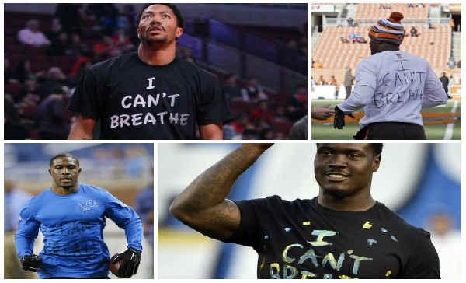

- How did social media help in Ukraine? What is going on now?

- Why are the residents of Venezuela unhappy with the current regime? How has the government handled their dissent?

- What are the two incidents that led to public outrage in the US? How were they similar? How were they different?

- In what way is social media an effective tool for a modern revolution?

- Identify an image from the article that emotionally impacts you and describe the feelings the photograph provokes. (Identify the mood and tone of the photograph and how it affects you.)

Socratic Seminar Questions: Use the bottom and back of this page for your answers. Be sure to number your answers.
- What are some different ways people attempt to resolve conflicts?
- What is the role of social media in our society?
- How does social media impact our society? Think of both the positive and negative impacts.
- How does point of view affect the way conflict is dealt with?

